**PHONICS TEACHING OVERVIEW**

**PHASE 1** (Revision during YR Autumn Term alongside Phase 2)

Early phonics teaching in pre-school, nursery and at the start of Reception focuses on developing children’s listening skills.

In Phase 1 phonics, children are taught about:

* Environmental sounds
* Instrumental sounds
* Body percussion (e.g. clapping and stamping)
* Rhythm and rhyme
* [Alliteration](http://www.theschoolrun.com/alliteration-assonance-consonance)
* Voice sounds
* Oral [blending](http://www.theschoolrun.com/what-is-blending) and segmenting (e.g. hearing that d-o-g makes ‘dog’)

Typical activities for teaching Phase 1 phonics include **'listening' walks, playing and identifying instruments, action songs, learning rhymes and playing games like I Spy**.

This phase is intended to develop children’s listening, vocabulary and speaking skills.

**Phase 2 p**

**PHASE 2** (YR Autumn 1 and Autumn 2)

In Phase 2, children begin to learn the sounds that letters make ([phonemes](http://www.theschoolrun.com/what-is-a-phoneme)). There are 44 sounds in all. Some are made with two letters, but**in Phase 2, children focus on learning the 19 most common single letter sounds**.

By the end of Phase 2 children should be able to read some [vowel-consonant (VC) and consonant-vowel-consonant (CVC) words](http://www.theschoolrun.com/cvc-words), and to spell them out. They also learn some [high frequency ‘tricky words’](http://www.theschoolrun.com/what-are-high-frequency-words) like ‘the’ and ‘go.’ This phase usually lasts about six weeks.

[www.phonicsplay.co.uk](http://www.phonicsplay.co.uk)



 

**PHASE 3** (YR Spring 1 and Spring 2)

Phase 3 introduces children to the remaining, more difficult and/or less commonly used phonemes. There are around 25 of these, mainly made up of two letters such as /ch/, /ar/, /ow/ and /ee/.

Alongside this, **children are taught to recognise more tricky words, including ‘me,’ ‘was,’ ‘my,’ ‘you’ and ‘they’.**They learn the names of the letters, as well as the sounds they make. Activities might include learning mnemonics (memory aids) for tricky words, practising writing letters on mini whiteboards, using word cards and singing songs like the Alphabet Song.

Phase 3 takes most children around 12 weeks. By the end, they should be able to say the sound made by most, or all, Phase 2 and 3 [graphemes](http://www.theschoolrun.com/what-is-a-grapheme), blend and read CVC words made from these graphemes, read 12 new tricky words and write letters correctly when given an example to copy.



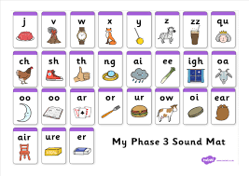 

By now, children should be confident with each phoneme.**‘From here on, phonics teaching is about consolidating and refining their knowledge, introducing more spelling patterns and tricky words, and increasing vocabulary,’**

**Phase 4** (YR Summer term alongside revision of Phase 2 & Phase 3)

In Phase 4 phonics, children will, among other things:

* Practise reading and spelling CVCC words (‘such,’ ‘belt,’ ‘milk’ etc)
* Practise reading and spelling high frequency words
* Practise reading and writing sentences
* Learn more tricky words, including ‘have,’ ‘like,’ ‘some,’ ‘little’

Children should now be blending confidently to work out new words. They should be starting to be able to read words straight off, rather than having to sound them out. They should also be able to write every letter, mostly correctly. This phase usually takes four to six weeks, and most children will complete it around the end of Reception.

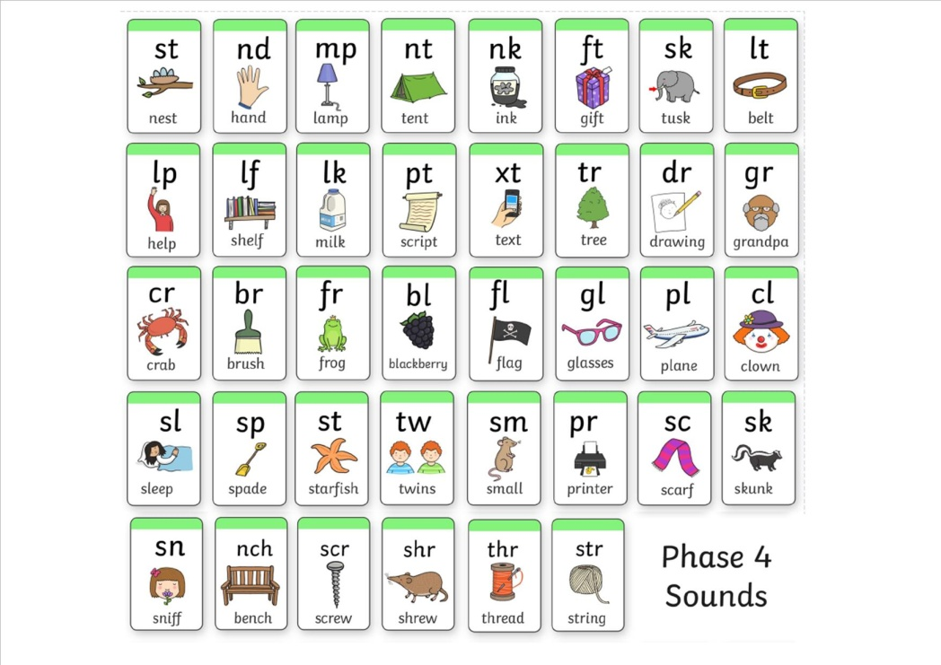**hase 5 phonics**

**Phase 5** (Year 1)

Phase 5 generally takes children the whole of Year 1. ‘Here, we start introducing alternative spellings for sounds, like 'igh',” says Sara. ‘Children master these in reading first, and as their fluency develops, we begin to see them using them correctly in spelling.’

Children learn new [graphemes](http://www.theschoolrun.com/what-is-a-grapheme) (different ways of spelling each sound) and alternative pronunciations for these: for example, learning that the grapheme ‘ow’ makes a different sound in ‘snow’ and ‘cow’.

**They should become quicker at blending, and start to do it silently.**

They learn about split [digraphs](http://www.theschoolrun.com/What-is-a-digraph) (the ‘magic e’) such as the a-e in ‘name.’

They’ll start to choose the right graphemes when spelling, and will learn more tricky words, including ‘people,’ ‘water’ and ‘friend’. They also learn one new phoneme: /zh/, as in ‘treasure.’

By the end of Year 1, children should be able to:

* Say the sound for any grapheme they are shown
* Write the common graphemes for any given sound (e.g. ‘e,’ ‘ee,’ ‘ie,’ ‘ea’)
* Use their phonics knowledge to read and spell unfamiliar words of up to three [syllables](http://www.theschoolrun.com/what-is-a-syllable)
* Read all of the 100 high frequency words, and be able to spell most of them
* Form letters correctly

[At the end of Year 1, all children are given a Phonics Screening Check](http://www.theschoolrun.com/year-1-phonics-screening-check) to ensure they have mastered the appropriate knowledge. 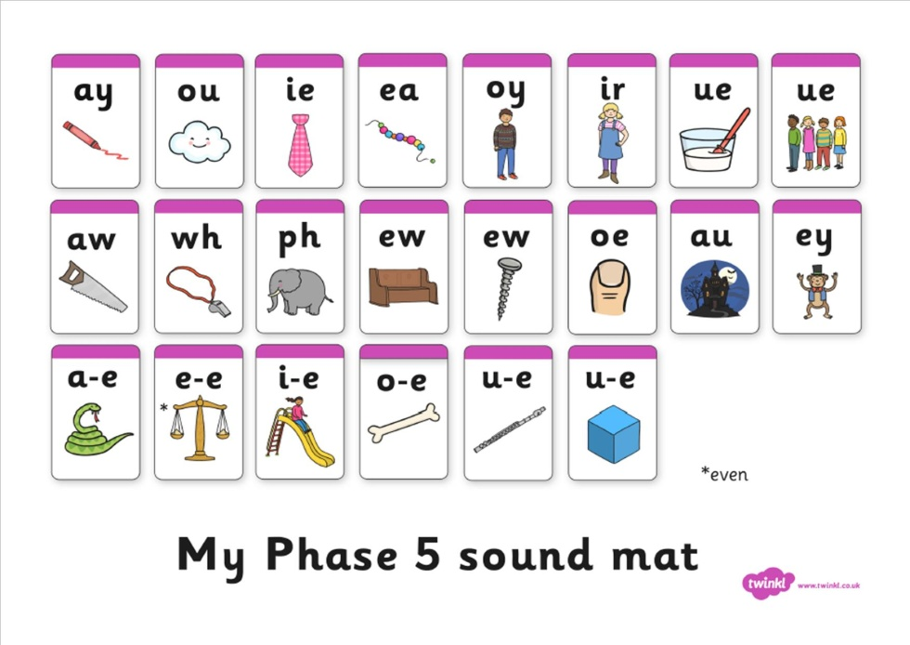

**Phase 6** Year 2 (alongside revision of Phase 2, 3, 4 and 5)

Phase 6 generally takes place for the whole of Year 2. The aim of this phase is for children to become fluent readers and accurate spellers.

By the end of Phase 6, children should be able to read hundreds of words using one of three strategies:

* Reading them automatically
* Decoding them quickly and silently
* Decoding them aloud

**Children should now be spelling most words accurately (this is known as '**[**encoding**](http://www.theschoolrun.com/what-is-encoding)**'), although this usually lags behind reading.**

They will also learn, among other things:

* [Prefixes](http://www.theschoolrun.com/what-is-a-prefix) and [suffixes](http://www.theschoolrun.com/what-is-a-suffix), e.g. ‘in-’ and ‘-ed’
* Spelling rules e.g. adding suffies to words / rules on how to change root words when adding these suffixes (for example, removing the 'e' from 'have' before adding 'ing') as well as harder concepts such as silent letters (**k**nock, **w**rite, etc) and particular endings (le in bottle and il in fossil).
* The [past tense](http://www.theschoolrun.com/what-is-verb-tense)
* Memory strategies for high frequency or topic words
* Proof-reading
* How to use a dictionary
* Where to put the [apostrophe](http://www.theschoolrun.com/what-is-an-apostrophe) in words like ‘I’m’

Although formal phonics teaching is usually complete by the end of Year 2, children continue to use their knowledge as they move up the school. **The whole aim of phonics teaching is not just to learn the sounds, but to use them as a tool for reading and spelling.** Everything leads on to independent reading and writing.’







Letters and sounds: High Frequency Words Checklist

(bold / highlighted = tricky words)

Phase 2

|  |  |  |  |  |  |
| --- | --- | --- | --- | --- | --- |
| a | an | as | at | if | in |
| is | it | of | off | on | can |
| dad | had | back | and | get | big |
| him | his | not | got | up | mum |
| but | the | to | I | no | go |
| into |  |  |  |  |  |

Phase 3

|  |  |  |  |  |  |
| --- | --- | --- | --- | --- | --- |
| will | that | this | then | them | with |
| see | for | now | down | look | too |
| he | she | we | me | be | was |
| you | they | all | are | my | her |

Phase 4

|  |  |  |  |  |  |
| --- | --- | --- | --- | --- | --- |
| went | It’s | from | children | just | help |
| said | have | like | so | do | some |
| come | were | there | little | one | when |
| out | what |  |  |  |  |

Phase 5

|  |  |  |  |  |  |
| --- | --- | --- | --- | --- | --- |
| don’t | old | I’m | by | time | house |
| about | your | day | made | came | make |
| here | saw | very | put | oh | their |
| people | Mr | Mrs | looked | called | asked |
| could |  |  |  |  |  |