Monday 30th March 2020 – Year 2 Home Learning
Year2@shelford.cambs.sch.uk
Subject | Activity | Submission
Spelling | Spell Check:  Last week’s spelling rule: The sound /zh/ spelt ‘s’.  Spelling words:  television treasure usual division measure usually  behind both break steak door sure  Bonus word: parliament  In your home learning books write today’s date at the top of the page and numbers one to thirteen on the left side of the page. If you don’t have your home learning book you can simply use paper available to you. An adult will read out each word to you and you will write the words next to the numbers just like we do at school! | Please submit a photo of this activity to the email address above by 3pm today.  Please include the following in the email subject box:  -Child Name  -Piece of Work  -Date
Literacy | Focus: Postcards  Prior to school breaking up we had been reading Flat Stanley and had written our own postcards from Stanley to his parents when he was on vacation in California.  I want you to apply what you learned about postcards to write and create your own postcard to let someone else know what you have been up to and how you are doing. You could choose to create a postcard and take a picture and send it to one of your classmates, family, friends or even staff at school.  Here is the template that we used when we wrote our own postcards. You can create your own postcard on a piece of paper around your home.  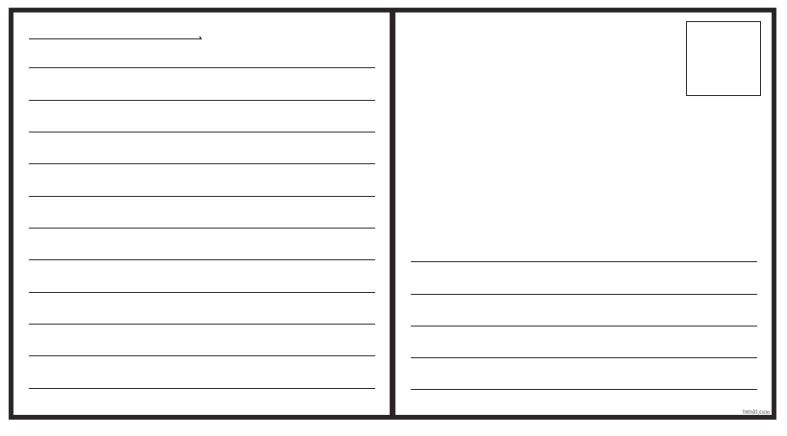  Key pointers:  - Make sure you write who the post card is to ( for example, Dear John,)  - Write in full sentences using capital letters and correct punctuation.  - Don’t forget to say who the postcard is from!  - Remember that post cards are not long!  - Have fun with it!
Maths | Current Unit: Properties of Shapes  Begin by going through the Maths 30.03.20 PowerPoint.  Children will do the starter activities at the beginning of the presentation in their home learning books. I have added a slide after the starters with the answers.  Next complete one of the following challenges from the Counting Edges on 3D Shapes worksheet in the home learning books. This sheet will not be posted on the Class Page due to copyright. Please do not feel that you need to print out the worksheets.  Challenge: Counting Edges on 3D Shapes (page 1)  Super Challenge: Counting Edges on 3D Shapes (pages 3-4)  Extreme Challenge: Counting Edges on 3D Shapes (page 5 and 7)
Other | Please choose one of the activities from the Family Home Learning Menu on the school website. You can find this learning menu in my email to parents as well.
Reading | Choose a book that you haven’t read before. Look at the cover with an adult and answer the following questions:  -What do you think this story will be about?  -Why do you think that? (What do they see on the cover that helps to support their prediction)  Read aloud the story with an adult.  -Was your prediction correct?  -If it was different, explain what happened instead.

