Friday 3rd April 2020 – Year 3 Home Learning
Year3@shelford.cambs.sch.uk
Subject | Activity | Submission
Reading  (approx. 30 minutes) | Learning Objective: I can identify how language, structure and presentation contribute to meaning.  Read 2 chapters/pages (whichever is the best challenge for you) of your current reading book/a book of your choice.  Which character in the book are you most like? Explain your answer.
Literacy and Numeracy  (approx. 2 hours) | Learning Objective: I can design and make a board game  It would be best to have a big piece of paper or card to do this activity, or you could draw your game across a double page of your home learning book.  - Draw your board game track around the board and number each of the squares. You need to have about 30 squares of track. Make each square quite big as you will need to write in some of the squares. Think about what shape your track will be. (I have put some ideas below). Mark on the START and FINISH.  - Every few squares you need to write an instruction for the player. They might need to miss a turn, jump forward two squares, jump back one square. Think of some stone age reasons why. For example:  You have caught a sabre tooth tiger. Jump forward 1 square.  You need to stop and mix some paint for your cave painting. Miss a go.  You have found a great flint to make an axe. Jump forward two squares.  You need to go and collect firewood. Jump back one square.  Your fishing spear has snapped. Miss a go.  - Decorate your board game with cave paintings, weapons, caves, stone age animals.  - Find someone in your house to play your game with you. What could you use for playing counters? Could you make two stone age tools or two stone age animals as the playing counters?  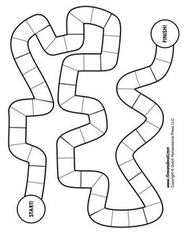  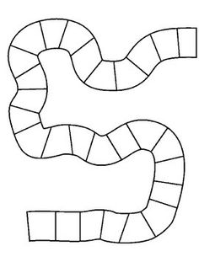 | Please submit evidence of the activity to the email address above by 3pm today.  Please include the following in the ‘email subject box’:  -Child Name  -Piece of work title  -Date
Choose something you and your family would like to do together from the Family Learning Menu on the School Website.
There are lots of suggestions there for fun activities and learning across the curriculum.

