Friday 3rd April 2020 – Year 2 Home Learning
Year2@shelford.cambs.sch.uk
Subject | Activity | Submission
Spelling | Spelling Review:  Year 2 Common Exception Words:  could should would cold gold hold  told behind many any water who  Copy this list into your home learning book. This is a perfect opportunity to practice your handwriting. Ask children to read these words out after they have copied them into their books.  Choose three different words that you haven’t used yet this week to write in a sentence. Remember to use your best handwriting, capital letters and correct punctuation to end your sentences (. ! or ?).  Please choose one of the spelling games to play. You could choose to play more than one if you would like!  **Please note there will be no spelling test the Monday back from Easter holidays.
Literacy | Grammar Hammer  Every two weeks in class we do a grammar hammer which I use to inform my planning. Similar to yesterday with maths, I would like the children to independently do a grammar hammer. You may read the questions to them but they need to answer the questions on their own. Please go over the answers once they are done and you have taken a photo. This will help me to determine which areas of grammar we need to practice after the Easter break. | Please submit a photo of this activity to the email address above by 3pm today.  Please include the following in the email subject box:  -Child Name  -Piece of Work  -Date
Maths | Problem Solving  Children will begin by solving the following questions in their home learning books or on paper if you don’t have your home learning books yet.  76+20= 45+38= 55-9= 68-30= 74-47=  12x1= 8x2= 3x0= 10x7= 18 ÷3= 25 ÷5=  Choose at least one challenge you would like to do (one star, two star or three star) and do all of the word problems for that challenge:  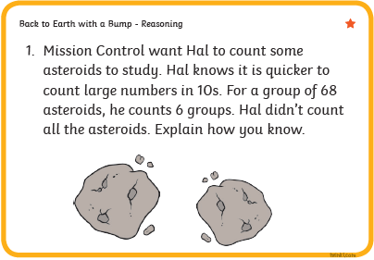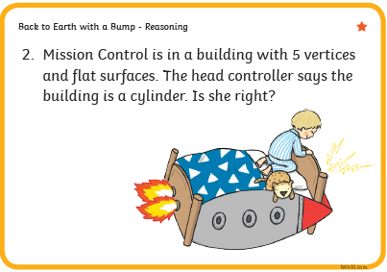  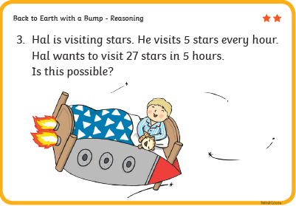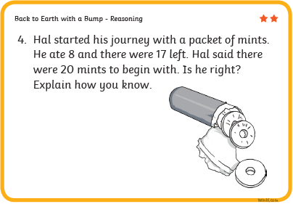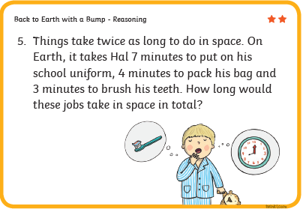  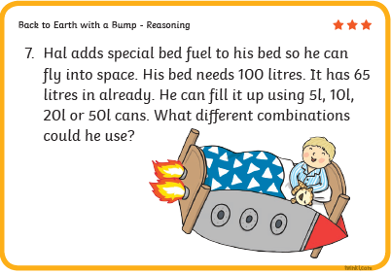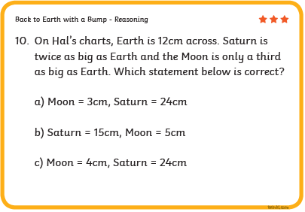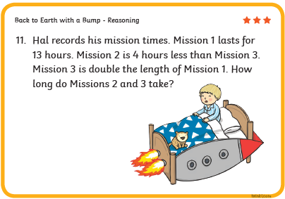
Other | Please choose one of the activities from the Family Home Learning Menu on the school website. You can find this learning menu in my email to parents as well.
Reading | Children read the Easter Reading Comprehension and answer the comprehension questions. Please only do one reading and one set of comprehension questions.  Please remind children that they still need to remember capital letters and full stops when answering questions.  Here is guidance for which challenge each reading group should be doing:  Willy Wonka: 3 Star  The Twits: 3 Star  Roly Poly Birds: 2 Star  Fantastic Mr Fox: 2 Star  Matilda Group: 1 Star  Please note that if your child wants to challenge themselves and do a harder reading comprehension I fully encourage this!  Once children have completed the challenge please go over the answers with them.

