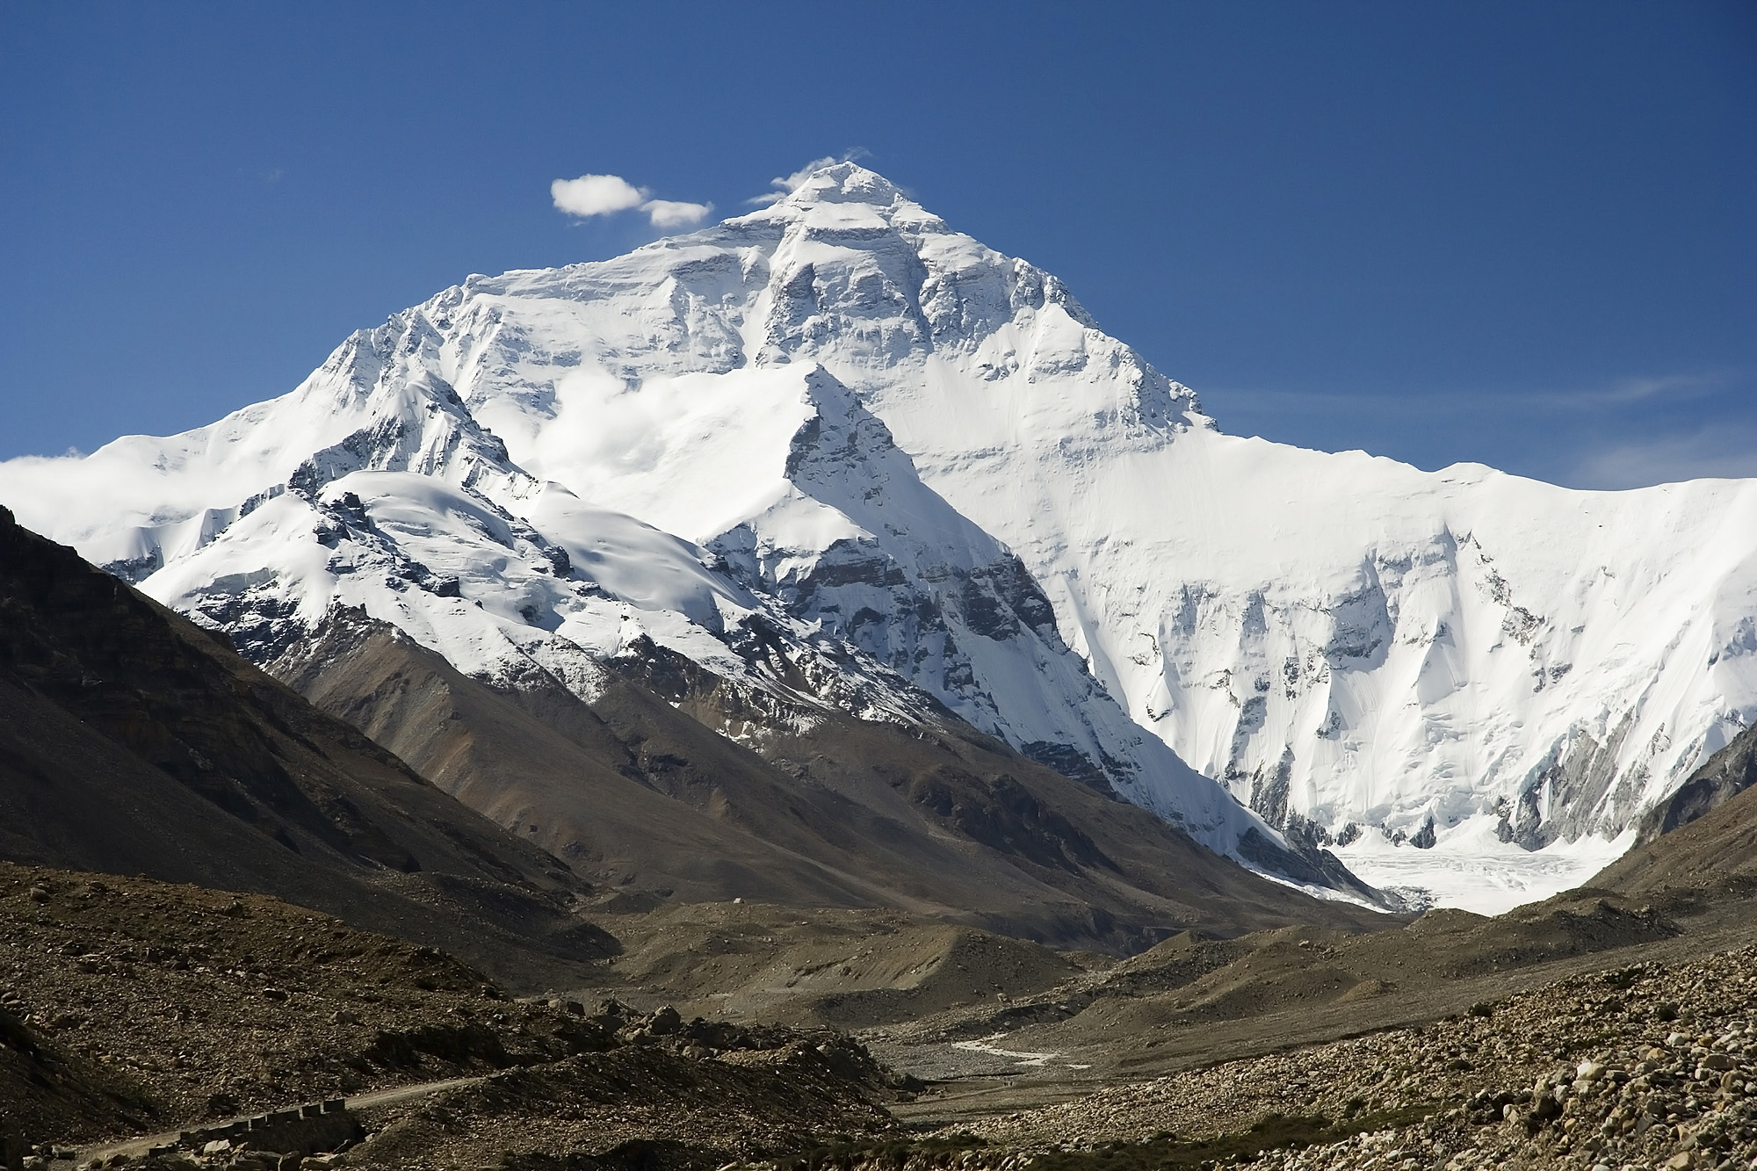

**PSHE –diversity and communities**

**RE-why do Christians call the day Jesus died Good Friday?**

**Maths –fractions of amounts and shape, understand place value of 3 digit numbers, adding 3 digit numbers using expanded addition, subtract a 2 digit number from a 3 digit using maths frog, measure in mm, cm, m and g and kg.**

**Music –** **Exploring Arrangements - create, combine and perform rhythmic and melodic material as part of a class performance of a song.**

**Computing – improve touch typing skills, use digital resources to explore a world map, creating digital images using paint**

**Geography– locate major mountain ranges on a World map, understand the difficulties faced by mountain climbers and how mountain climbing has changed during the past 80 years, think about the similarities and differences between their lives and life in the Kumaon Himalayas. To study a locality in a less economically developed country.**

**Art** – Mountains painted by artists in the past – Hokusai, Albert Bierstadt, Nicholas Roerich, Seurat, Cezanne; pictures of endangered mountain animals using collage.

Mighty Mountains

**Literacy- writing instructions on how to climb a mountain – using imperative verbs and adverbials of time; writing adventure stories using chapters.**

**PE** –gymnastics – pathways, Indoor athletics

**Science**- electricity and circuits; endangered mountain environments and animals

Please note these are planned activities and not all areas may be taught

**French**-actions and body parts

**History** – the ascent of Mount Everest