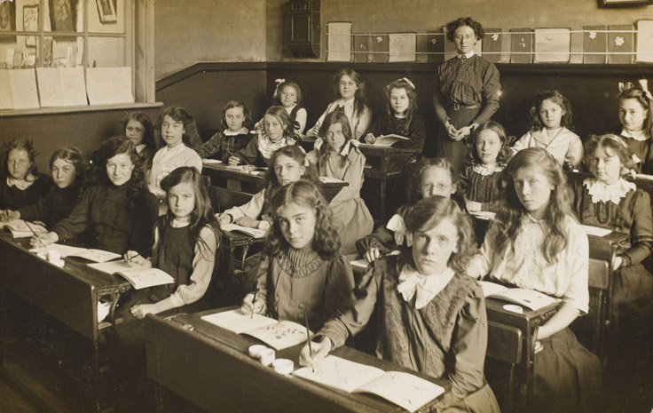

**PSHE Digital Wellbeing**

**Computing- branching databases**

**Literacy- Retelling the legend of St George and the dragon, dragon poems,**

**Non-fiction writing- explanation of how a robot dog works**

**Art- Victorian Art- the work of William Morris, making printing tiles inspired by nature, creating repeated printing patterns, portraits by Kehinde Wiley using a William Morris background**

**RE-Why is prayer important to Muslims and not to some people? The 5 pillars of Islam, how and why do Muslims pray? What does the Salah tell us about Muslim beliefs and ways of life?**

**DT** -– pneumatic systems. Creating a monster with jaws that open and shut

**Maths –fractions- recognising unit and non-unit fractions, adding fractions, equivalent fractions, ordering fractions**

**Telling the time**

**History** – the history of our school, from Victorian times to the present day. Dressing up for a Victorian school day.

**French**-classroom objects and instructions

**Music –Food and Drink**

The History of Our School

**PE –athletics and outdoor and adventurous activities**

**Science**- understanding plant life processes and habitats

Please note these are planned activities and not all areas may be taught