Friday 27th March 2020 – Year 2 Home Learning
Year2@shelford.cambs.sch.uk
Subject | Activity | Submission
Spelling | This week’s spelling rule:  The sound /zh/ spelt ‘s’.  Spelling words:  television treasure usual division measure usually  behind both break steak door sure  Bonus word: parliament  Begin by reading these words aloud to an adult.  Choose three of these words to write sentences with in your home learning books. (Different from the past three days)  Enjoy the Leisure Cove Phonics PowerPoint!  Please note that you don’t have to use this PowerPoint. This is just meant to help you as parents if you are wanting to use it.
Literacy | Current Unit: Poetry  Children are going to write their poems today!  Look over the following ‘What am I?’ poem together. Can children point out any of the describing words that give more information about the noun (the animal)? Can they identify any similes? Can they spot any verbs? Can they find adjectives? Look at the structure and features of the poem together.  What am I?  I have bright eyes as big as dinner plates.  I have enormous, powerful flippers.  I swim through the oceans.  I have hard, unbreakable armour.  I retreat into my safe shell.  I have wrinkly skin as green as emeralds.  I have a round, stout body.  What am I?  Children will use all of their work from the previous days to write a ‘What am I?’ poem. Encourage children to look back at their work they completed this week-they have already done all of the hard work!  Please share the following success criteria with them:  -Capital Letters and Full Stops  -Structure (like the example above)  -Starting sentences with I  -Use of verbs  -Use of expanded noun phrases  -Title  -At least seven lines (can be longer)  Challenge: Can you use similes in your poem?  I will be sharing these poems on our class page so that others may try to guess their animal so they will need to make sure they describe their animal very well! | Please submit a photo to the email address above by 3pm today.  Please include the following in the email subject box:  -Child Name  -Piece of Work  -Date
Maths | Problem Solving  Children will begin by solving the following questions in their home learning books or on paper if you don’t have your home learning books yet.  38+74= 84+16= 21-8= 45-27=  Fridays are going to be our problem solving days during our home learning journey. I have chosen three different challenges. Your child can choose their own challenge. They must do at least one but can do as many as they would like. Please complete these in your home learning book.  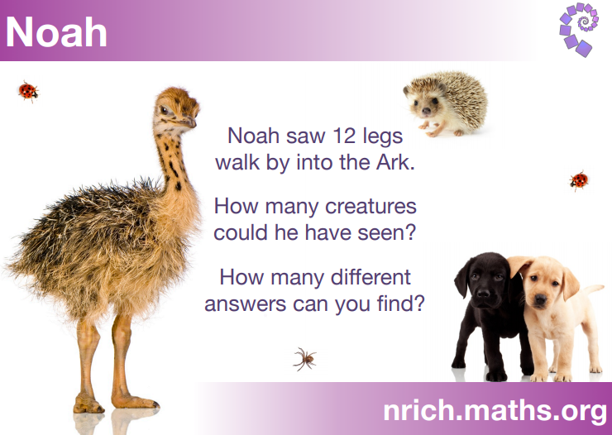  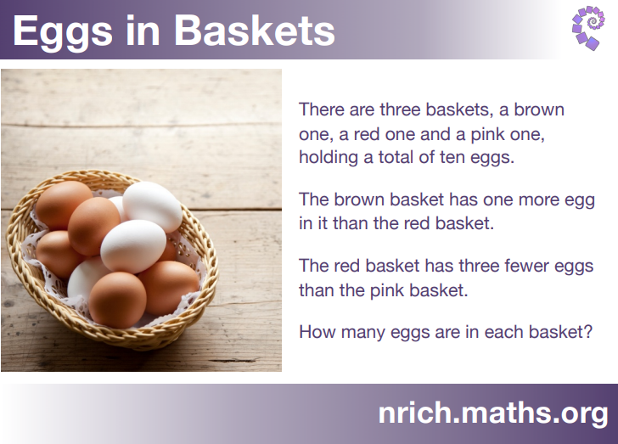  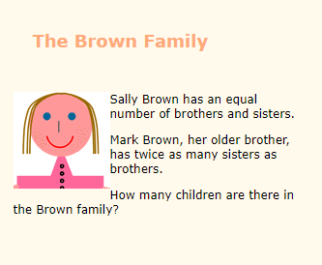
Other | RE: Easter  Please complete one of the RE Easter activities from the Resources tab under Home Learning.
Reading | Read aloud to someone at home for 15 minutes.  Once you are done describe the setting of your story. Look at what you have read. Are there any good words describing the setting? If there aren’t any words can you describe the setting from the pictures? You could use your adjective word bank from earlier in the week to help you!

