No Screen Days Family Learning Menu
Photography  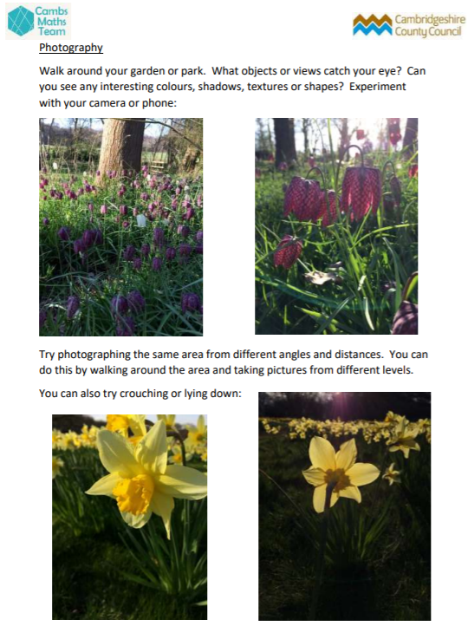 | Garden Project  Be an Explorer  Be a Designer  Be a Mathematician  Be a Scientist  Be a Writer  Be an Artist  Be a Sportsperson  Who will you be today? Follow the link (by clicking on the image below) to find lots of activities, where you can be creative and imaginative outside.  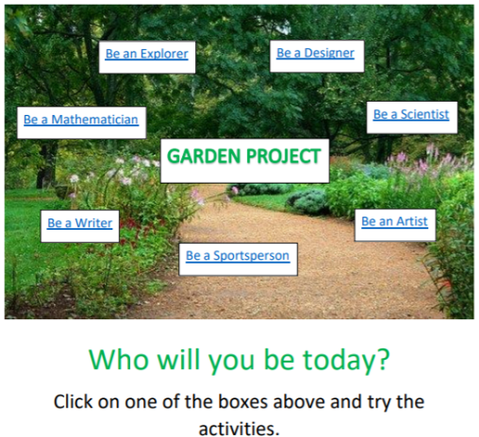 |  |  |  |  | Shadow Art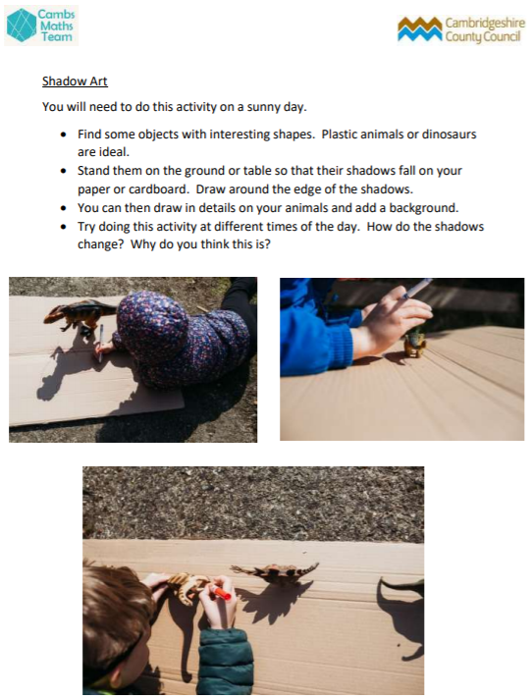
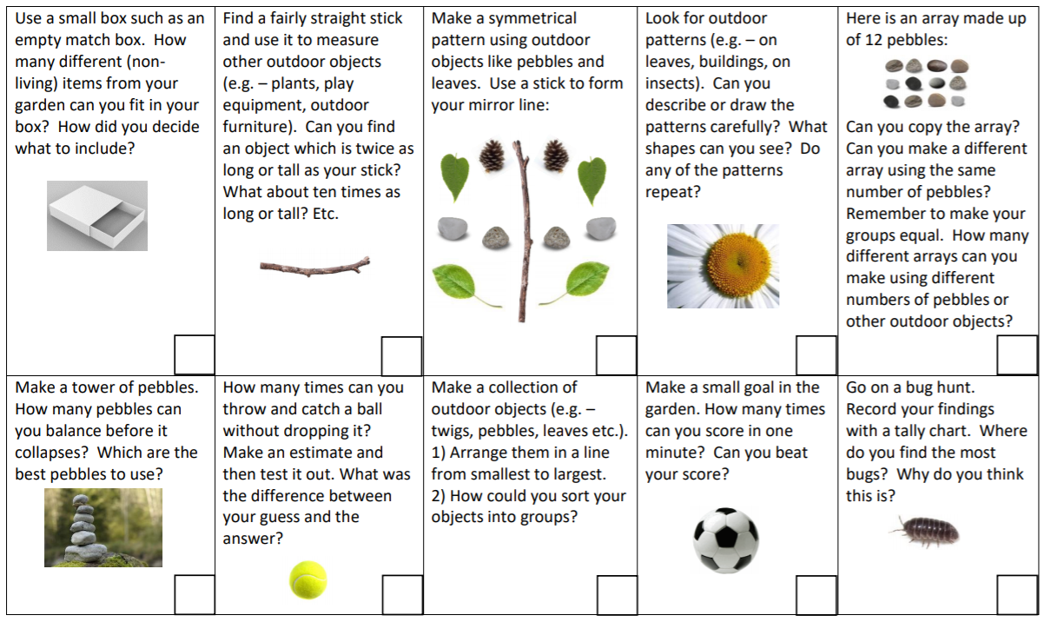  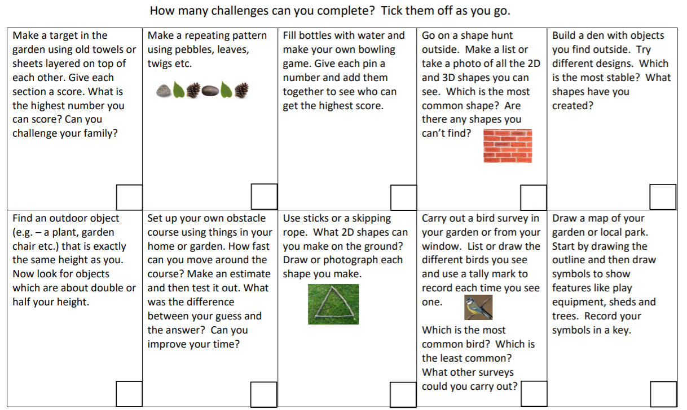  Numeracy – KS1 |  | Numeracy – KS2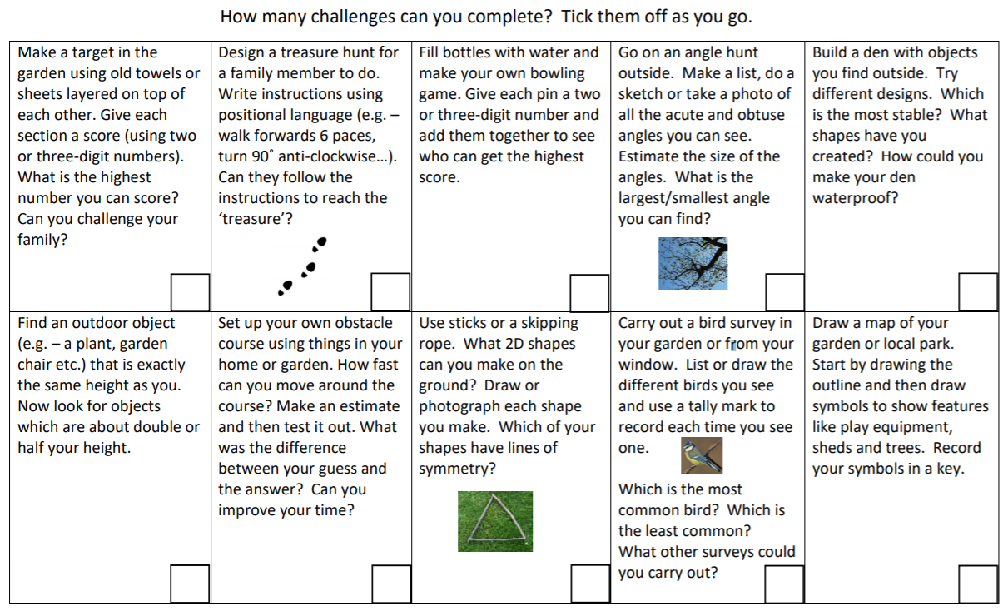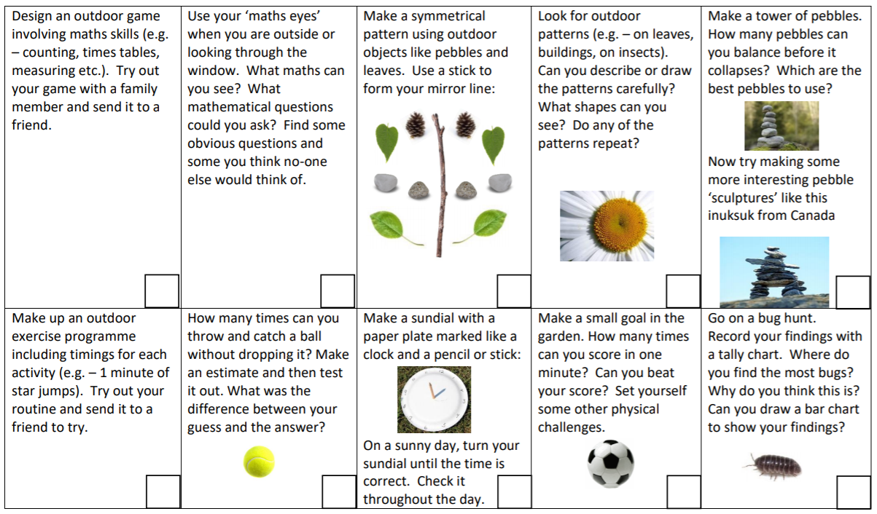
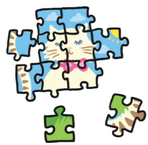  Make a puzzle  Cut up a picture from a magazine, a hand-drawn picture or even a photograph into different shapes to make your own puzzle |  | 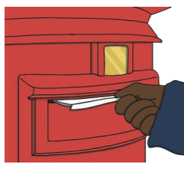Literacy – Writing  Write to a friend or family member. Tell them any news you have, what you have been doing lately. You may even like to draw a picture. Pop it in a stamped, addressed envelope and mail it when you can
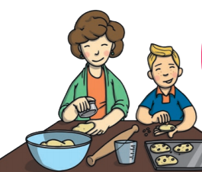  Design Technology - Get Baking  Choose a recipe of something you like to eat. With an adult, take care to measure out the ingredients and follow the recipe. |  |  |  |  | Paint Mixing - gradients  You will need:  - White, yellow and red paint;  - Paper  - Scissors  - Paintbrush  - Water  - Paper plate / surface to mix on  - Cut out a strip of paper (shaped like a snake if you wish).  - Think about the strength of the colours of your paints:  - White = milk - not strong, you can use lots;  - yellow = mustard - a bit spicy –use a little;  - red= chili – very spicy – just use a tiny bit!  - See if you can create a gradient from white, to yellow, to red, using careful, gradual mixing.
Shard Art
Print off / find a black and white line drawing. You could use Van Gogh’s line drawing of his bedroom. Cut out a small triangle about the size of a £2 coin. Stick this somewhere on a piece of white paper (e.g. A5 or A4)

Can you extend and replicate the patterns within your shard to disguise / camouflage it on the page? Can someone in your family spot where the original shard is?
Art – Ink Blowing  You will need:  - Poster paint (2-3 colours)  - Water  - Straws  - Thick paper or card  - Mix a little water into your poster paints.  - Spoon or carefully tip a little of each colour onto your thick paper or card.  - Use the straw to blow the paints together.  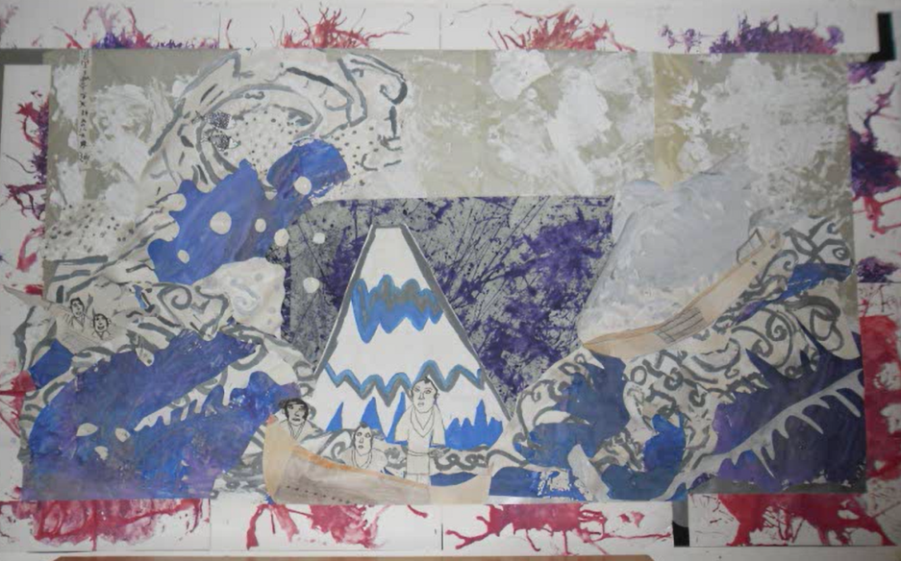  - As the paints mix and move, you may start to see some unusual shapes. Can you recognise something there? Maybe it’s a sea creature, an alien, plant, a landscape or a monster! You could even create different parts to create a piece of artwork like the one here that was inspired by Hokusai’s Great Wave artwork. |  |  |  | Take Notice - Forest School  Cloud-bathing  Just like sunbathing… with clouds!  - As you lie back and look at the sky, what can you notice?  - Can you spot any familiar shapes or patterns?  - What do you notice about how the clouds are moving?  - What do you feel right now?  - Can you spot some of the different types of clouds below?  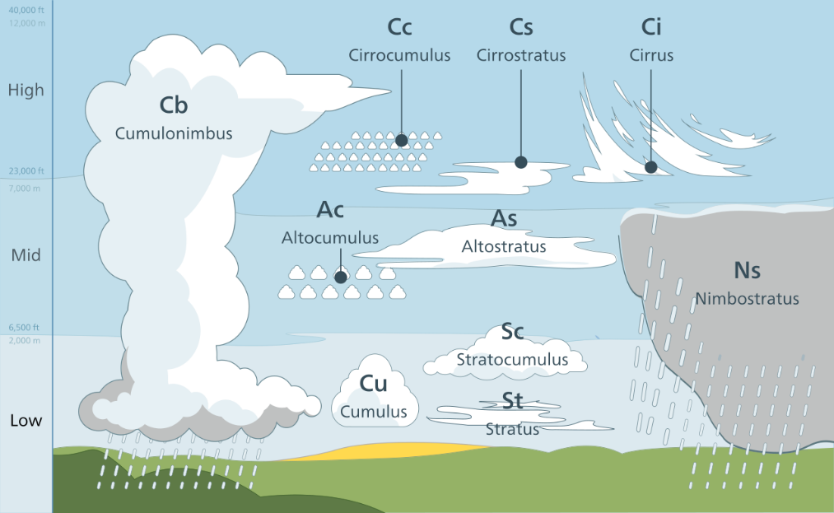
Shelford Star Challenge!  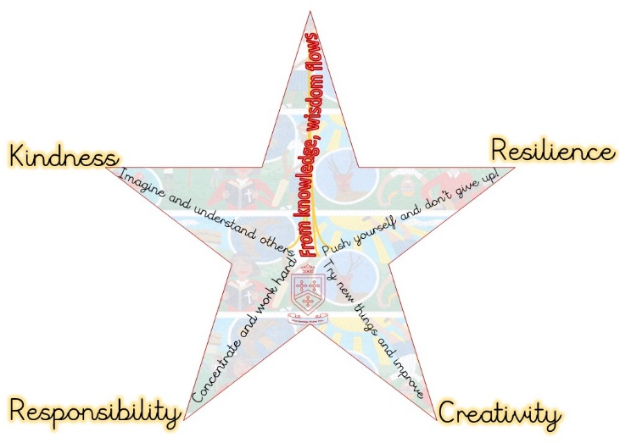  Can you challenge yourself to demonstrate one of our star values in a big way!?  How would you demonstrate extreme kindness, super creativity, extra resilience and fantastic responsibility? The possibilities are endless!  Feel free to send in your examples to office@shelford.cambs.sch.uk |  |  | Play a Board Game  Playing board games promotes teamwork, family bonding, problem-solving, and specific skill sets depending on the goal of the game. They also teach your children how to lose, how to juggle multiple tasks at once, and how to follow directions. You could even design and make your own board game.  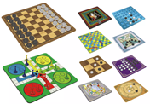
Be a Nature Spotter  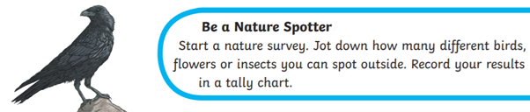 |  |  | 25 fun reading and writing activities  You may like to choose one of the 25 fun reading and writing activities below  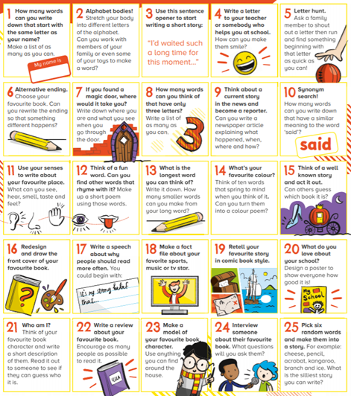
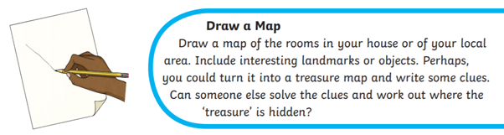
Signs of spring
Make a list of the things that spring is:
List 1: What things LOOK spring?
List 2: What things SOUND spring?
List 3: What things SMELL spring?
List 4: How does spring FEEL ?
List 5: What makes YOU FEEL spring?
List 6: What things TASTE spring?
List 7: What EXPERIENCES or IDEAS seem
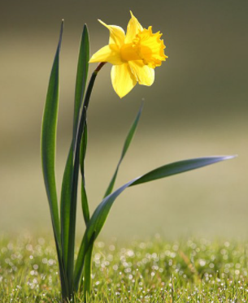
spring?

