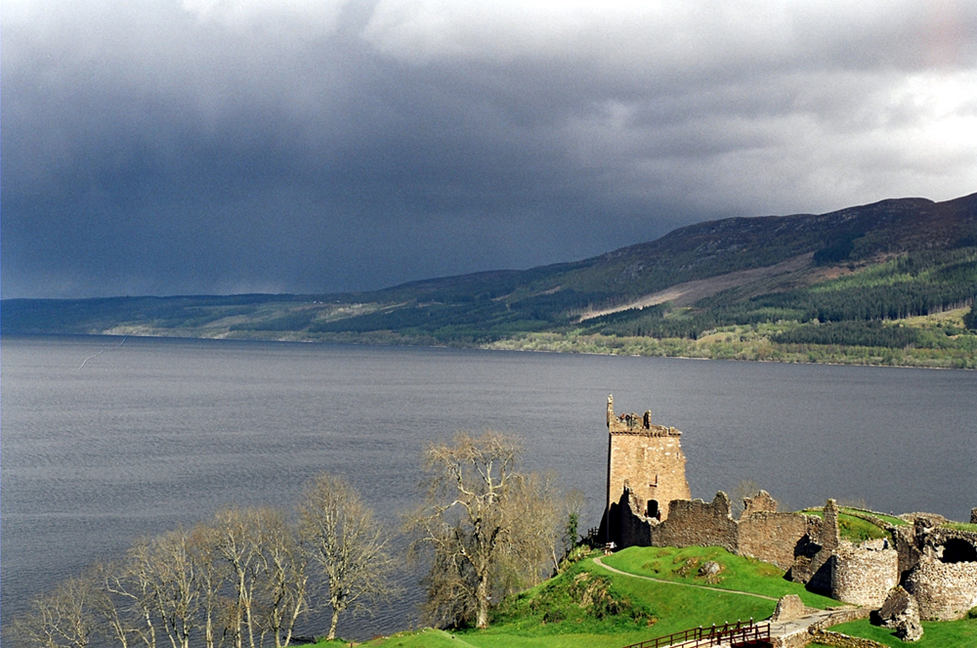

**Science**- The human skeleton, sound

**Literacy – interview of an eyewitness account of seeing the Loch Ness Monster, writing letters to and from Father Christmas**

Inverness

**Geography –the countries and capital cities of the UK, similarities and differences between Shelford and Inverness, the formation of Loch Ness, the Loch Ness monster**

**Computing – sending and receiving emails**

**Art** –Scottish Art- looking at the weaving process to create tartan, designing our own tartan pattern, clay Loch Ness Monsters, Steven Brown’s McCoo’s.

**PE-**  gymnastics, dance

Please note these are planned activities and not all areas may be taught

**French** –body parts, the weather

**Maths – the 3 times table, adding two digit and three digit numbers using regrouping in column addition, subtraction finding the difference between two numbers and column subtraction, division, addition and subtraction word problems**

**Music: The human body, tuned and untuned percussion accompaniment**

**PSHE – family and friends, anti-bullying week, Odd Socks Day**

**RE – People of God- Noah. What is it like to follow God?**

**DT** – designing, making and evaluating Christmas stockings