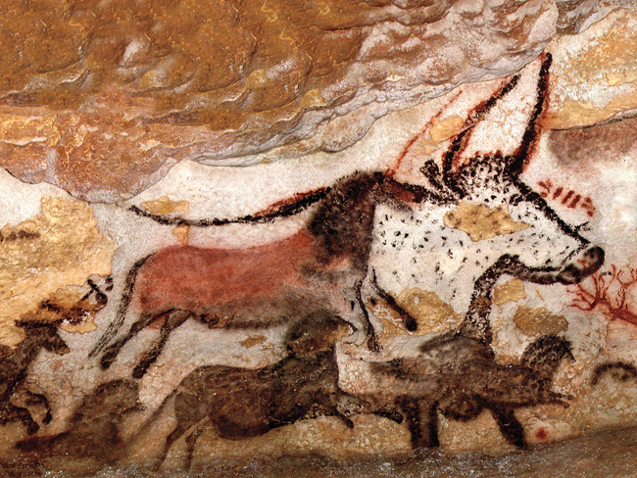

PSHE: Diversity and Communities

**Literacy:** writing a tome travel story inspired by “Stone Age Boy” by Katoshi Satamura, World Book Day

Design Technology: investigating pop up mechanisms to design an Easter card with a pop up centre

Stone Age to Iron Age

Year 3 Spring 2

Class Trip to Wandlebury for Iron Age Day

**Numeracy**: Statistics, length and perimeter, fractions

**Music:** French songs

RE: Why do Christians call the day Jesus died Good Friday?

**PE:** dance and racket and ball skills

**French**: animals and colours

**History**: timelines from stone age to iron age, the move from hunter gathering to farming, Stonehenge and Skara Brae, finds at Much Farm, class trip to Wandlebury hill fort

**Science:** Rocks and Fossils, Properties of materials

**Computing**: coding

**Art:** using chalk and charcoal to create cave paintings, using clay to create pinch pots in the style of grooved ware found in Orkney