Family Learning Menu – Spring 1 - 2021
English – Speaking and Listening  Speak in rhymes  How many rhymes can you come up with? Can you speak in rhyming words?  Mystery picture  Work in pairs. Player 1 needs a pencil and paper. Player 2 needs a picture book. Make sure you can’t see each other’s resources! Player 2 picks a picture from the book and has to describe it to player 1 who needs to draw what is being described. Make sure your descriptions are detailed. | English – Reading  Book scavenger hunt.  Find a book:  Set in space  Written in First Person  With a Magical Theme  All Characters are animals  - What other categories can you think of?  Create a comic strip to go with your favourite story/current reading book. |  |  | English Writing  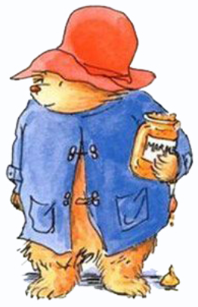  Create the main character for a book. What are their distinguished features? (e.g. Harry Potter – glasses & scar).  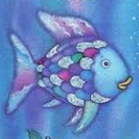  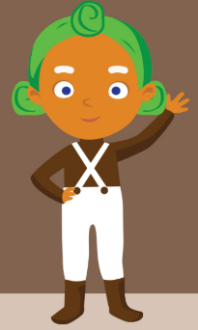  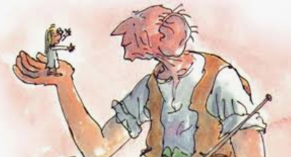  Explore collective nouns for animals.  Create artwork and/or poem to represent these.  Eg. An ambush of tigers  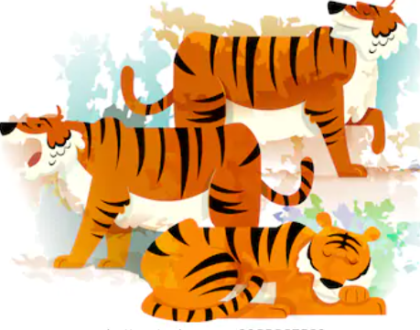
Maths – Shape, Space Measure  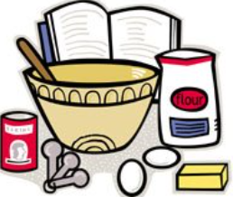  Make a clock! You could make it out of recycled materials. Each number could be a different shape. You could have a theme for your clock or colour code it.  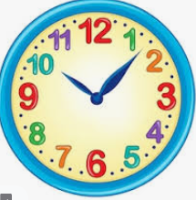  Follow a recipe and look closely at the measurements used. Extension If you recipe is enough for 4 people, see if you can change the measurements so it will be enough for 6! |  |  |  |  |  | Maths – Number  Dice game.  Roll a pair of die to create a two digit number and see if you can make a target number in 5 rolls. For example: Target number – 200. Will you add, subtract, multiply, divide your two digit numbers to make 200.  Guess my number  Use post-its or paper and give players a number to put on their forehead. Don’t let them all see the numbers chosen! Players have to guess their number from the clues given by other participants.
RE  Create a poster representing a prayer. It could be a prayer that is already written or you could produce your own. Remember TSP to help you? A prayer can be: to say thank you, sorry or to praise.  Symbols  Look closely at the symbols for some of the world’s largest religions. Do you notice any similarities or differences? Is there one you like more? Why? Discuss the symbols with a family member. Maybe you want to research them further. Or even come up with a symbol to represent you and/or your beliefs!  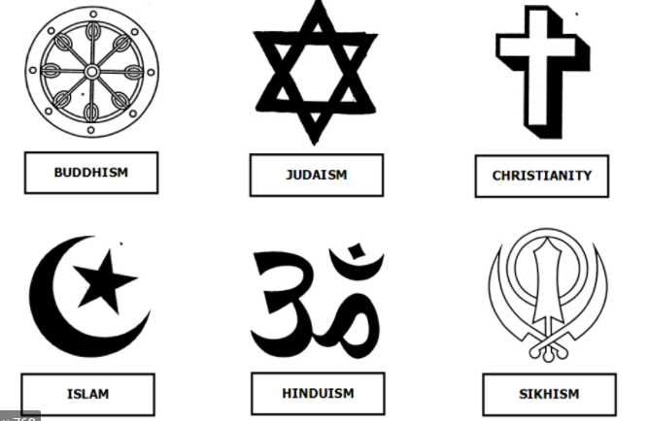 |  |  |  |  |  | Science  Take part in the RSPB Bird Watch, Get creative with some bird craft activities too.  Make a bath bombs or slime on the Blue Peter makes and bakes page.  Earth, Sun, Moon  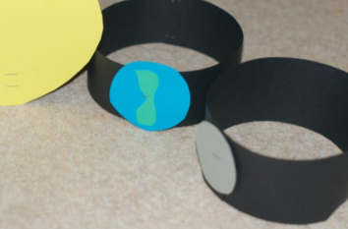  You need three people for this: one to be the Sun, one to be the Earth and one to be the Moon. Together you can act out part of our solar system. Use paper or card to make a band to fit around your head and secure it with staples or tape. Stick on a circle of card and colour it to show if you are the Sun, Earth or Moon. The Sun stands in the middle, the Earth orbits (goes round) the sun and the Moon orbits the Earth. You could do this indoors or outside.
Internationalism  Flags  How many world flags could you recognise? Research and quiz yourself! Colour in templates.  Cinderella  Did you know there are lots of different versions of Cinderella from all over the world?  Watch this version and compare. Perhaps create your own! |  |  |  |  | Take 5 – Wellbeing  - Take Notice – Get out in nature for the RSPB Bird Survey.  - Be Active – take a look at the PE section  - Connect – call/FaceTime/Zoom a friend or relative |  |  |  | Forest School  Make a woodland theatre.  Create a wildlife quiz. You could have a section about trees or animals.  Decorate a tree.  Find out the age a of a tree near you!
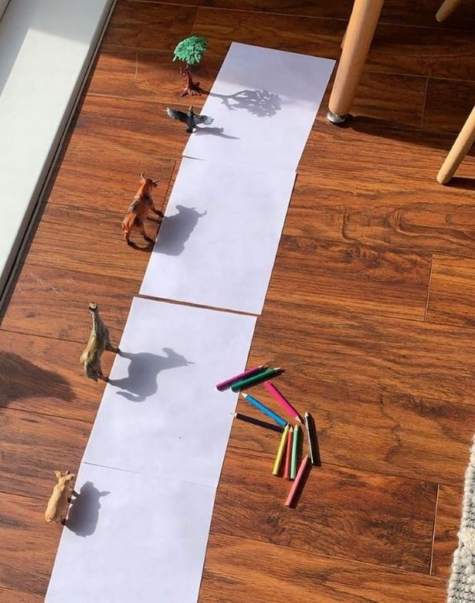 |  | Art/DT  Create some shadow drawings by placing some figures carefully on a piece of paper by a window or use a lamp and draw around their shadows. Add colour and a background!  Make a junk elephant! Cut the bottom off the bottle and cut arches into the back and sides to make the legs, then chop the handle so it looks like a trunk.  Discover fun makes and bakes with Blue Peter. |  |  |  |  |  |  | 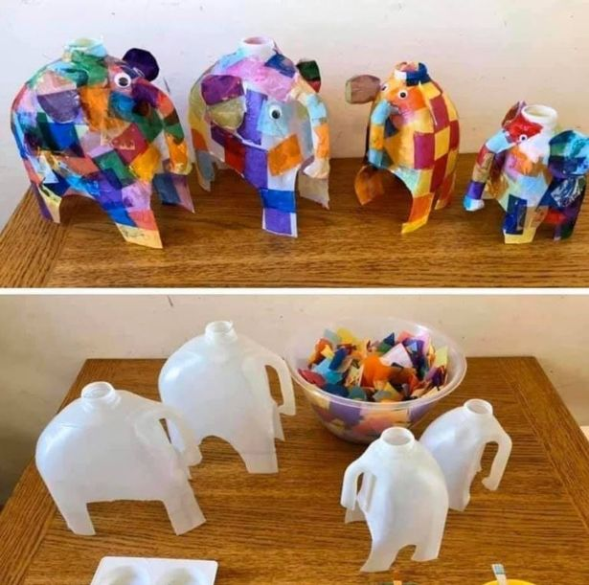
Humanities – History & Geography
Create your dream holiday island out of papier mache (or any materials you desire!) Which geographical features will your island have? Mountains/Volcanoes/Beaches/Jungle
Discover the midwinter party challenge from the Scott Polar Research Institute

Watch the clip of Barnaby Bear helping out on a mountain rescue. Create a poster highlighting how to keep safe when mountain climbing.

Discover some astonishing activists.

Design your own family crest.

Create your own great tower.

PSHE  Read The Happy Newspaper. Download the resource pack to create your own version! |  |  |  |  |  |  | MFL  Create a clock and write the numbers in French underneath each digit!  How many different ways can you say ‘hello’ different languages?
Music  Pick an activity from the music home learning menu. |  |  | PE  - Dance with Bruno Tonioli from Strictly!  - Active 8 with the Bodycoach Joe Wicks.  - 10 minute Disney Shake Up Games! |  |  |  |  | Computing  Explore these excellent  mini missions from  Barefoot Computing to build computational thinking skills.

