Year 2 2016-17
Information for parents

It has been a pleasure to meet your child this term and I am looking forward to teaching them over the course of this year.

Year 2 Teaching Team

Mr Dagnall, Teacher; Mrs Kellock, HLTA (every morning and Wednesday afternoon); Mrs Unwin, Teacher (Thursday afternoons)

Timetable

A typical weekly timetable in Year 2 will look like this:

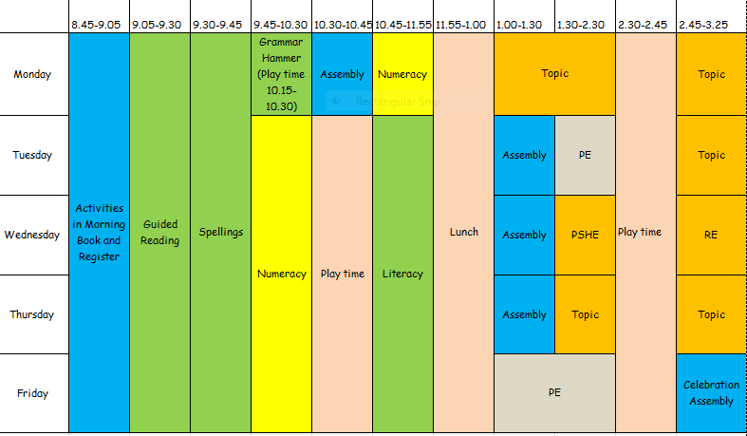

Topics

This year the topics (which we share with Year 1) are:

- All About Me
- Celebrations around the World
- Toy Story
- Clothes
- Pirates
- The Seaside

If you have any experience which would be relevant to these topics, and you would be willing to share that with us, we would be very pleased to invite you in to work with the children.

Reading

Please continue to read daily with your child at home. Attached is a breakdown of the targets that we will be working on in class and your support with these at home would be extremely valuable. We will be continuing to use the same Reading Records that your child had in Year 1 and will seek to emphasise the importance of their ongoing reading journey.

Guided reading sessions will take place daily and I will work with each group over the course of the week. Each group will also have the opportunity to change books and read with Mrs Kellock every week. We are very grateful for the support of parents and other volunteers who we will also ask to assist with reading whenever possible.

Other elements of the guided reading carousel are:
- Paired reading with Year 5 children
- Handwriting practice
- Reading Journal work – follow up from guided reading session

Homework/Learning Logs

In addition to daily reading at home and spelling (given out on Fridays and checked on Mondays), one piece of work will be set each week on a Friday. A sticker with the task will be stuck into the Learning Logs and, when appropriate, will be supported by additional notes. It should be brought back to school by the following Wednesday.

I always enjoy reading children’s homework, but the weekend is also a time to rest and have fun so children should spend no more than 20 minutes on a piece of homework! If your child is unable to complete the homework for any reason, please write me a note to let me know. This will avoid unnecessary anxiety on the part of your child.

Times tables

Children in Year 2 are expected to know their x2, x5 and x10 tables fluently by the end of the year. I have already seen that the children are familiar with these and we will practise them regularly in class. If you could support your child’s learning with the times tables, this will be invaluable this year and beyond. One resource, which we will use in class, is an app called Percy Parker where we sing along with the times tables; this is available for iPad and, if you can bear the catchy tunes, your child might well enjoy singing their times tables at home!

Class Bear

Year 2 will be joined this year by a bear who will have the chance to accompany every children home for a weekend over the course of the year. The children will be asked to write a diary of their weekend with the bear so that we can share his experiences! He will join Mr Dagnall for the holidays so that he is kept busy with new experiences!

PE

The two lessons of PE will take place on Tuesdays and Fridays. Children need to bring their PE kit to school every week (shorts, House T shirt, plimsolls or trainers and tracksuits for colder weather) which can be left in the cloakroom. Long hair must be tied back for PE lessons.

Class assemblies

- Parent briefing and class presentation in celebration assembly – Friday 25th November at 2.15pm
- Class presentation, parent briefing and celebration assembly – Friday 10th February at 1.30pm

Contact

If you have any concerns or queries, please speak to me or send a message. You will be able to find me at the door of the classroom every morning for quick messages, and I would be happy to meet with you at greater length on Wednesday, Thursday or Friday afternoons.

David Dagnall

