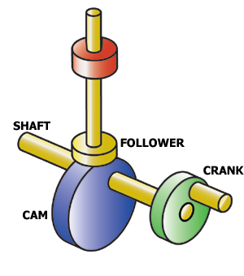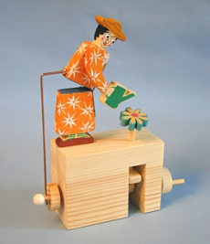

Great and Little Shelford CE Aided Primary School. Year 6 summer term project

Literacy

Instructional texts – how to build and how they work.

Short story for young children illustrated by the cam toy eg boat on the sea.

Science

Review of circuit knowledge including circuit diagrams and symbols.

Switches and the various ones that could be used in the model.

Gears and gearing up and down.

Pulleys and drive belts.

History

What were the early cam toys like?

How were they powered?

What themes were used?

What backgrounds?

Hand cranks and pulleys

Art

Backgrounds to the cam toys box, relevant to the toy. Eg seascape for a jumping fish.

Music

Music to go with the motion that your model makes, possibly as part of the short story.

Cam Toys

ICT

Research types of toys that use a cam mechanism. Scrap book of ideas including how they might have been decorated.

Performance opportunity: in class presentation of working models to either parents or another class.

Technology

Planning a toy with diagrams and materials lists.

Measuring, cutting and joining wood and card.

Fabric for some parts possibly.

The drive system – gears or a pully or a simple 1:1 ratio handle to turn.

Mock ups of the cam and drive systems.

Support structures using a box.

Support structures using a built frame and corner reinforcement techniques.