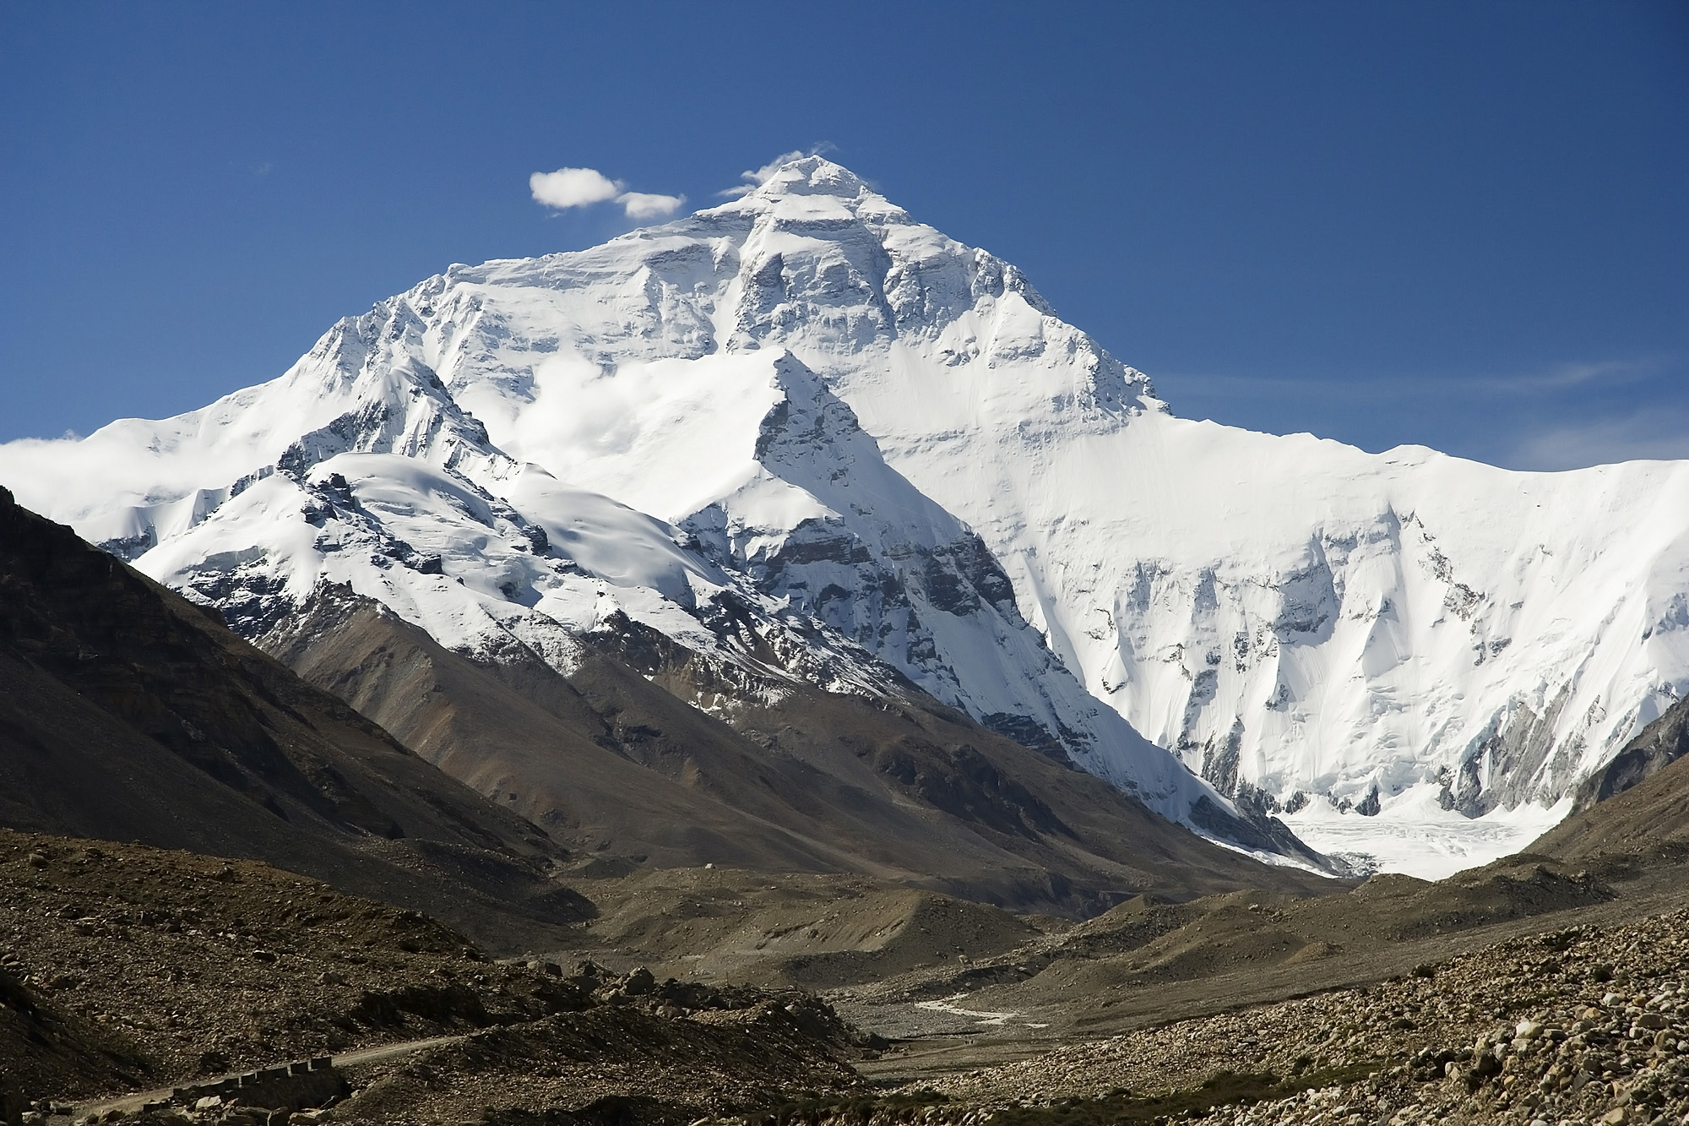

**PE** –rugby and racket skills

**History** – the ascent of Mount Everest

**PSHE –personal safety**

**RE: What is the Trinity?**

**Maths –multiplication and division, money, statistics, length and perimeter**

**Music –** Salt, Vinegar, Mustard, Pepper- exploring singing games

**Computing – improve touch typing skills, use digital resources to explore a world map, creating digital images using paint, desk top publishing**

**Geography– locate major mountain ranges on a World map, understand the difficulties faced by mountain climbers and how mountain climbing has changed during the past 80 years, think about the similarities and differences between their lives and life in the Kumaon Himalayas. To study a locality in a less economically developed country.**

**Art** – how to achieve a sense of perspective, looking at the prints of Mount Fuji by Hokusai, Metzinger landscapes, pictures of endangered mountain animals using collage.

Mighty Mountains

**Literacy- writing instructions on how to climb a mountain – using imperative verbs and adverbials of time; writing adventure stories using chapters.**

**Science**- magnets, endangered mountain environments and animals

Please note these are planned activities and not all areas may be taught

**French**-actions and body parts