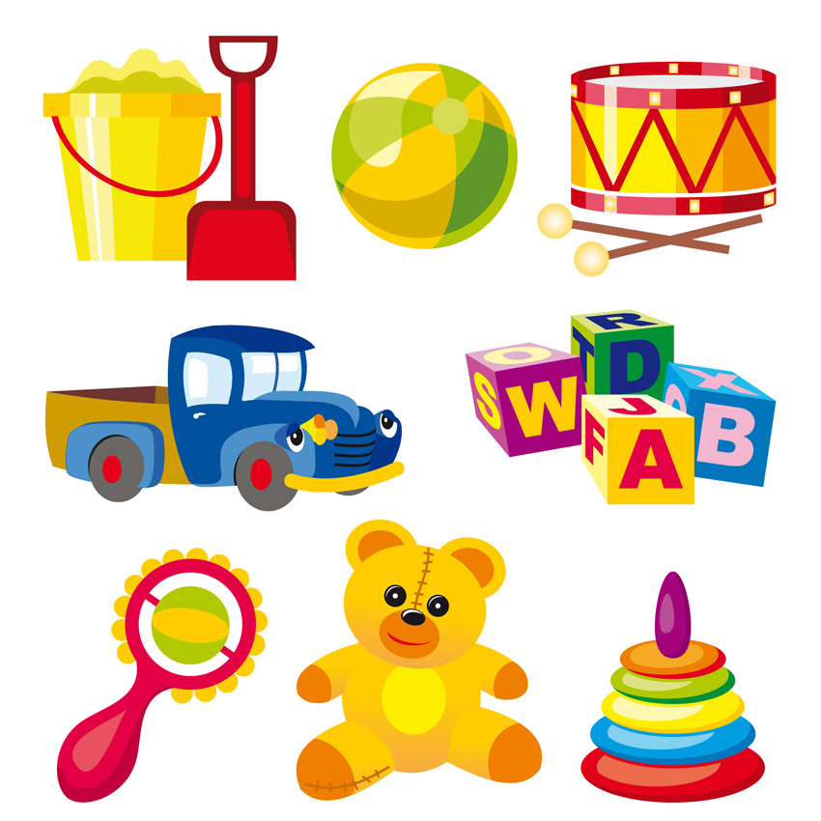

Literacy: Traditional stories from other cultures

Instructions

Poetry: The senses

PSHE:

Identity and Diversity

**Numeracy:**

**Number and Place Value; Multiplication and Division; Addition**

**Daily Maths Meetings**

PE:

Toy dances

Gymnastics: Balancing

Science:

Forces- describe basic movements

Experiments with pushes and pulls; falling objects; floating objects

Toy story

Dianne Conway to visit with old toys

Role Play Areas:

Toy shop

e

Design and Technology:

To make bridges and Rube Goldberg machines

RE:

Jesus: Who was Jesus – a great teacher or leader?

Art:

Toy printing based on Andy Warhol’s prints.

History:

Development of toys over time.; timelines

Music:

Sounds interesting – exploring sounds

Geography

Distinctive toys from other countries